



**Spelling Test: Year 3**

**Spellings given:** 15/11/2022

**Test On:** 22/11/2022  
Spelling Rule: Adding suffixes beginning with vowel letters to words of more than one syllable. The consonant letter is not doubled if the syllable is unstressed..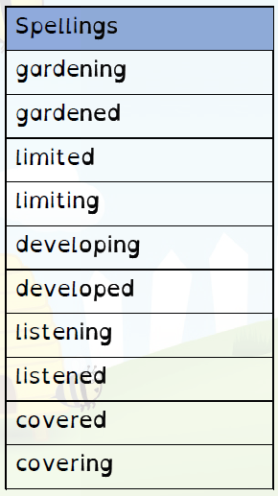



**Spelling Test: Year 4**

**Spellings given:** 15/11/2022

**Test On:** 22/11/2022  
Spelling Rule: Adding ‘-ly’ to to turn an adjective into an adverb when the final letter is ‘l.’’

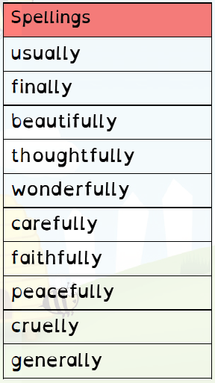

Remember, Mrs Duffy uploads your spellings weekly on to Spelling Shed. So, you can practise on the website or app too!