Spelling Test: Year 3
Spellings given: 22/11/2022
Test On: 29/11/2022
Spelling Rule: Adding suffixes beginning with vowel letters to words of more than one syllable. If the last syllable of a word is stressed and ends with one consonant letter which has just one vowel letter before it, the final consonant letter is doubled.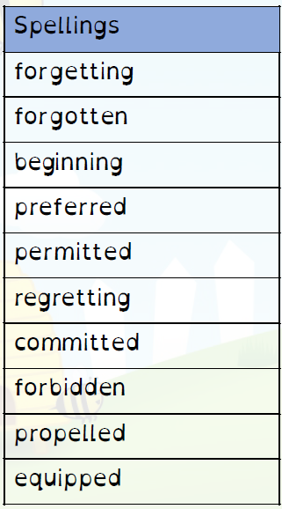

Spelling Test: Year 4
Spellings given: 22/11/2022
Test On: 29/11/2022
Spelling Rule: Word with the ’sh’ sound spelled ch. These words are French in origin.

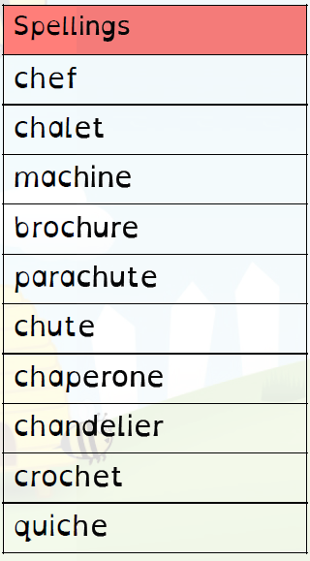

Remember, Mrs Duffy uploads your spellings weekly on to Spelling Shed. So, you can practise on the website or app too!

