Spelling Test: Year 3
Spellings given: 29/11/2022
Test On: 06/12/2022
Spelling Rule: Challenge Words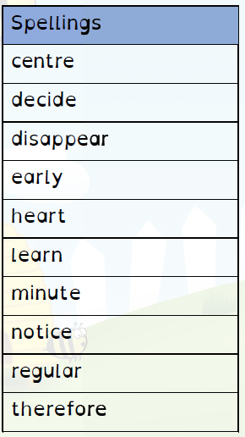

Spelling Test: Year 4
Spellings given: 29/11/2022
Test On: 06/12/2022
Spelling Rule: Challenge Words

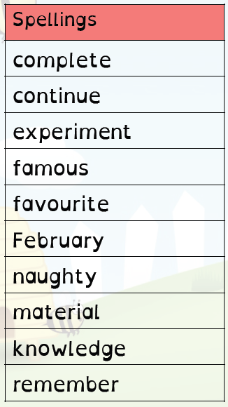

Remember, Mrs Duffy uploads your spellings weekly on to Spelling Shed. So, you can practise on the website or app too!

