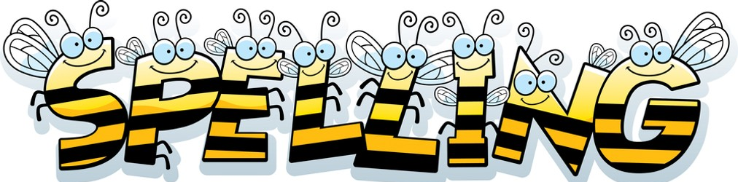

Spelling Test: Year 3
Spellings given: 06/12/2022
Test On: 13/12/2022
Spelling Rule: The long vowel /a/ sound spelled ‘ai’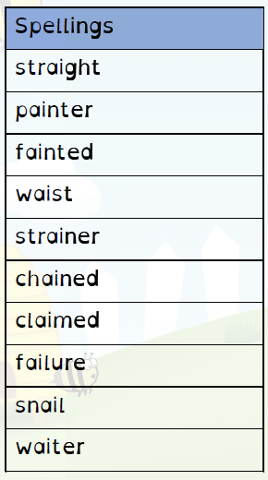

Spelling Test: Year 4
Spellings given: 06/12/2022
Test On: 13/12/2022
Spelling Rule: Adding the suffix ‘–ion.’ When the root word ends in ’d,’ ‘de’ or ‘se’ then the suffix ’-ion’ needs to be ‘-sion.’

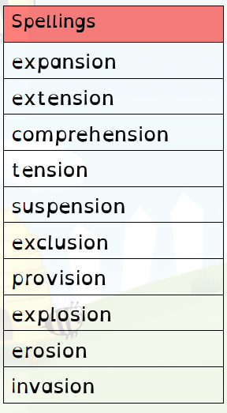

Remember, Mrs Duffy uploads your spellings weekly on to Spelling Shed. So, you can practise on the website or app too!

