Spelling Test: Year 4
Given: 30.03.2021
Test: 20.04.2021
Rule: High frequency words

Spellings
house
now
called
your
could

Spelling Test: Year 3
Given: 30.03.2021
Test: 20.04.2021
Rule: Homophones
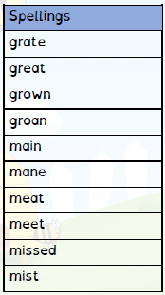

Spelling Test: Year 4
Given: 30.03.2021
Test: 20.04.2021
Rule: The suffix ‘-ous’ If there is an ‘ee’ sound before the ’-ous’ ending, it is usually spelled as i, but a few words have e.

Spellings
serious
obvious
curious
hideous
spontaneous
courteous
furious
various
victorious
gaseous

