Spelling Test: Year 3
Given: 15.09.20
Test: 22.09.20
Spelling Rule: The /nk/ sound found at the end of words. This sound usually comes after a vowel.

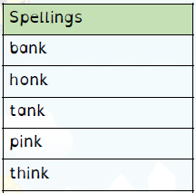

Spelling Test: Year 4
Given: 15.09.20
Test: 22.09.20
Spelling Rule: The prefix ’in-’ can mean both ‘not’ and ‘in’/’into.’ In these spellings the prefix ’in-’ means ‘not.’
Spelling Test: Year 3
Given: 15.09.20
Test: 22.09.20
Spelling Rule: The /u/ sound spelled ‘ou.’
This digraph is only found in the
middle of words.
