Spelling Test: Year 3
Spellings given: 13/09/2022
Test On: 20/09/2022
Spelling Rule: The /u/ sound spelled ‘ou.’ This digraph is only found in the middle of words
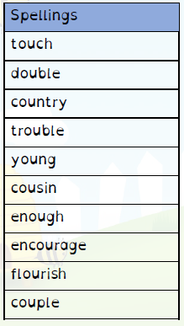
Remember, Mrs Duffy uploads your spellings weekly on to Spelling Shed. So, you can practise on the website or app too!

Spelling Test: Year 4
Spellings given: 13/09/2022
Test On: 20/09/2022
Spelling Rule: The prefix ’in-’ can mean both ‘not’ and ‘in’/’into.’ In these spellings the prefix ’in-’ means ‘not.’

