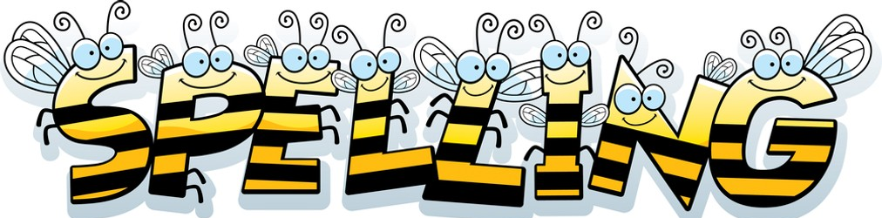
I’m so sorry for the delay in uploading the spelling test this week. The bank holiday has thrown me. Apologies, Mrs Duffy

Spelling Test: Year 3
Spellings given: 02/05/2023
Test On: 09/05/2023
Spelling Rule: Words where the digraph 'sc' makes a /s/ sound
Spellings
science
scene
discipline
fascinate
crescent
scissors
ascends
scented
scenery
descend
Remember, Mrs Duffy uploads your spellings weekly on to Spelling Shed. So, you can practise on the website or app too!

Spelling Test: Year 4
Spellings given: 02/05/2023
Test On: 09/05/2023
Spelling Rule: Words with the prefixes ‘super-’, ‘anti-’ and ‘auto-’

Spellings
supermarket
superstar
superhuman
antiseptic
anticlockwise
antisocial
autobiography
autograph
automatic
superhero

