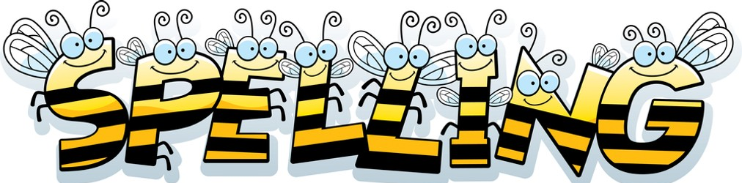

Spelling Test: Year 3
Spellings given: 09/05/2023
Test On: 16/05/2023
Spelling Rule: Words that are homophones
Spellings
ball
bawl
berry
bury
brake
break
fair
fare
mail
male
Remember, Mrs Duffy uploads your spellings weekly on to Spelling Shed. So, you can practise on the website or app too!

Spelling Test: Year 4
Spellings given: 09/05/2023
Test On: 16/05/2023
Spelling Rule: Words with the prefix ‘bi-’ meaning ‘two’

Spellings
bicycle
biplane
biped
bicentennial
biannual
bilingual
biceps
binoculars
bisect
biscuit

