Spelling Test: Year 3
Spellings given: 20/09/2022
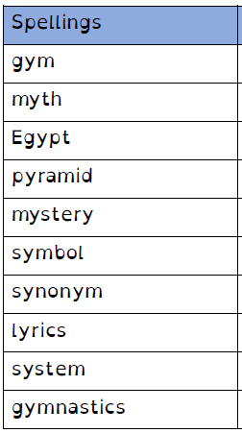
Test On: 27/09/2022
Spelling Rule: Spelling Rule: The /i/ sound spelled with a ‘y.’
Remember, Mrs Duffy uploads your spellings weekly on to Spelling Shed. So, you can practise on the website or app too!

Spelling Test: Year 4
Spellings given: 20/09/2022
Test On: 27/09/2022
Spelling Rule: Before a root word starting with l, the ‘in-’ prefix becomes ‘il-’. Before a root word starting with r the prefix ‘in-’ becomes ’ir-’

