Given: 09.06.20
Test: 16.06.19
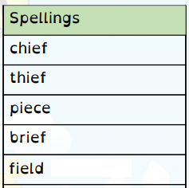
Spelling Test: Year 3
Spelling Test: Year 4
Given: 09.06.20
Test: 16.06.19

Given: 09.06.20
Test: 16.06.19
Spellings
accidentally
breathe
century
consider
eight
guard
heard
peculiar
possible
quarter

Spellings
bicycle
biplane
biped
bicentennial
biannual
bilingual
bicuspid
biceps
binoculars
bisect

