Given: 16.06.20
Test: 23.06.20
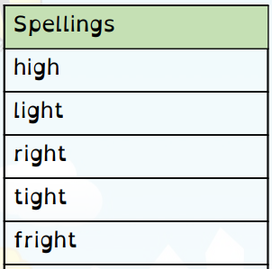
Spelling Test: Year 3
Spelling Test: Year 4
Given: 16.06.20
Test: 23.06.20

Given: 16.06.20
Test: 23.06.20
Spellings
difficult
important
length
perhaps
position
pressure
question
strange
special
purpose

Spellings
accept
inactive
illegal
submarine
interact
calendar
information
adoration
sadly
usually

