Given: 23.06.20
Test: 30.06.20
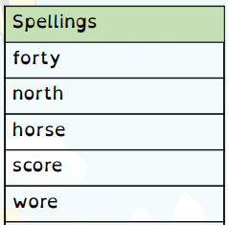
Spelling Test: Year 3
Spelling Test: Year 4
Given: 23.06.20
Test: 30.06.20

Given: 23.06.20
Test: 30.06.20
Spellings
difficult
important
length
perhaps
position
pressure
question
strange
special
purpose

Spellings
girls'
boys'
babies'
children’s
men’s
mice’s
ladies’
cats’
women’s
geese’s

