Given: 30.06.20
Test: 07.07.20
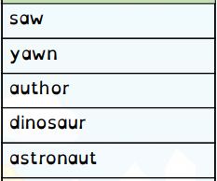
Spelling Test: Year 3
Spelling Test: Year 4
Given: 30.06.20
Test: 07.07.20

Given: 30.06.20
Test: 07.07.20
Spellings
pleasure
island
dislocate
disadvantage
decide
survey
exactly
bravely
ordinary
promise

Spellings
expression
musician
reluctantly
group
scene
circle
solar
supermarket
bicycle
except

