Spelling Test: Year 3
Spellings given: 27/09/2022
Test On: 04/10/2022
Spelling Rule: Words with endings that sound like /ze/, as in measure, are always spelled with ‘-sure’.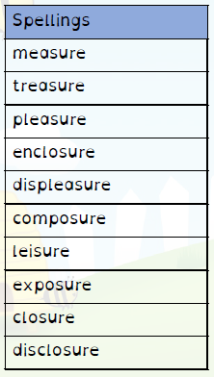
Remember, Mrs Duffy uploads your spellings weekly on to Spelling Shed. So, you can practise on the website or app too!

Spelling Test: Year 4
Spellings given: 27/09/2022
Test On: 04/10/2022
Spelling Rule: The prefix ‘sub-’ which means under or below.

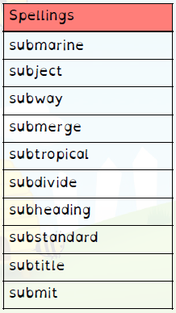

Remember, Mrs Duffy uploads your spellings weekly on to Spelling Shed. So, you can practise on the website or app too!

