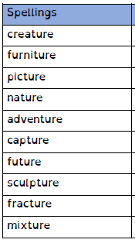
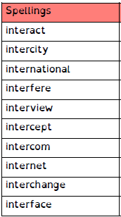
Spelling Test: Year 3
Given: 05.10.21
Test: 12.10.21
Rule: Words with endings that sound like /ch/ is
often spelt –’tu re’
Spelling Test: Year 4
Given: 05.10.21
Test: 12.10.21
Rule: The prefix ‘inter-’ means between, amongst or during.

