Spelling Test: Year 3
Spellings given: 04/10/2022
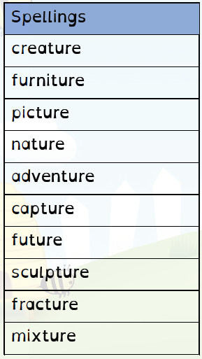
Test On: 11/10/2022
Spelling Rule: Words with endings that sound like /ch/ is often spelt –’ture’ unless the root word ends in (t)ch.
(t)ch.

Spelling Test: Year 4
Spellings given: 04/10/2022
Test On: 11/10/2022
Spelling Rule: The prefix ‘inter-’ means between, amongst or during.

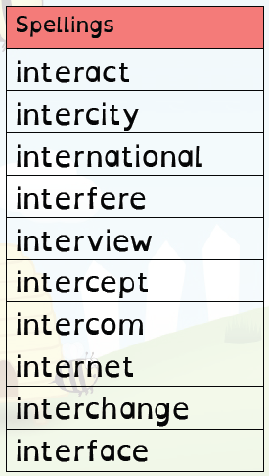

Remember, Mrs Duffy uploads your spellings weekly on to Spelling Shed. So, you can practise on the website or app too!

