Spelling Test: Year 3
Spellings given: 11/10/2022
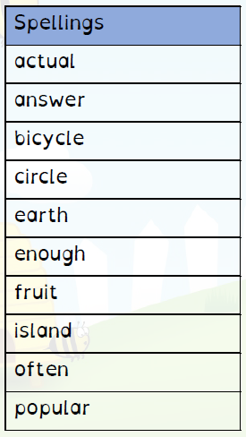
Test On: 18/10/2022
Spelling Rule: Challenge words

Spelling Test: Year 4
Spellings given: 11/10/2022
Test On: 18/10/2022
Spelling Rule: Challenge words

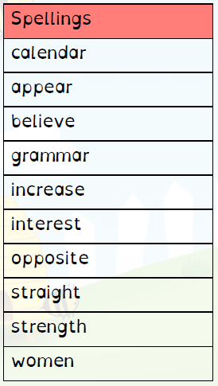

Remember, Mrs Duffy uploads your spellings weekly on to Spelling Shed. So, you can practise on the website or app too!

