Spelling Test: Year 3
Spellings given: 18/10/2022
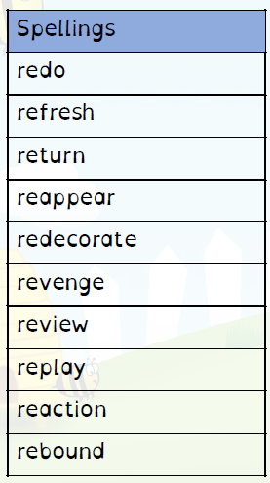
Test On: 01/11/2022
Spelling Rule: Words with the prefix ’re-’ ‘re-’ means ‘again’ or ‘back.’

Spelling Test: Year 4
Spellings given: 18/10/2022
Test On: 01/11/2022
Spelling Rule: The suffix ’-ation’ is added to verbs to form nouns.

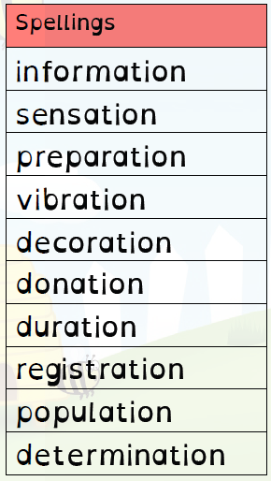

Remember, Mrs Duffy uploads your spellings weekly on to Spelling Shed. So, you can practise on the website or app too!

