Spelling Test: Year 4
Given: 10.11.20
Test: 17.11.20
Spelling Rule: The /ai/ and /oi/ digraphs

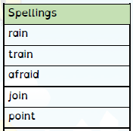

Spelling Test: Year 3
Given: 10.11.20
Test: 17.11.20
Spelling Rule: The prefix ’mis-’ This is another prefix with negative meanings.
Spellings
misbehave
mislead
misspell
mistake
misplace
misread
mistrust
misunderstanding
misuse
mislaid

Spelling Test: Year 4
Given: 10.11.20
Test: 17.11.20
Spelling Rule: Adding –ly to make adverbs. Remembering words ending in ‘-y’ become ‘-ily’ and words
ending in ‘–le’ become ‘–ly.’

Spellings
sadly
completely
wildly
bravely
gently
foolishly
proudly
horribly
nervously
happily

