Spelling Test: Year 3
Spellings given: 08/11/2022
Test On: 15/11/2022
Spelling Rule: The prefix ’mis-’ This is another prefix with negative meanings.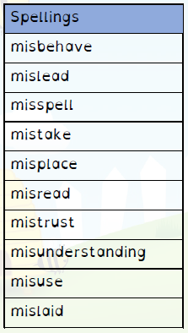

Spelling Test: Year 4
Spellings given: 08/11/2022
Test On: 15/11/2022
Spelling Rule: Adding –ly to make adverbs. Remembering words ending in ‘-y’ become ‘-ily’ and words ending in ‘–le’ become ‘–ly.’

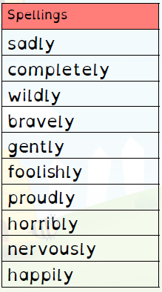

Remember, Mrs Duffy uploads your spellings weekly on to Spelling Shed. So, you can practise on the website or app too!

