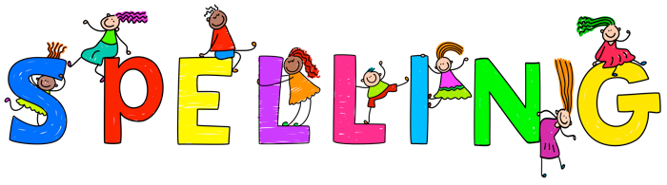
Class 4 spellings are given out on a Tuesday and are tested on the following Tuesday. Your child can play set games on Spelling Shed to help them learn them or/and complete their own practise at home.
Your children are rewarded, in school, if they get 80% or more correct.

