ANSON CE PRIMARY SCHOOL

Main Road
Great Haywood
Stafford
ST18 0SU Tel no: 01889 881200
Email: office@anson.staffs.sch.uk"
Headteacher: Miss N. Jarrett

Dear Parents/Carers,

Welcome back to a new school term. Our topic this term will be Wonderful Winter and a focus on ‘The Gingerbread Man’ and ‘Superheroes’ in Literacy. You can find details of our intended learning over the page.

Class Information:

Before and After school routines: The school gates are open from 8.30am, Class 1 children should line up and enter at the blue Early Years gate in the playground. They will be greeted by a member of the early years team and led into the classroom. At the end of the day please collect your child from this same gate, where children will be dismissed one at a time to their collecting grown up. Please make sure you are visible to the member of staff and you come to the gate to collect your child. Please notify the office if a different person will be collecting your child and ensure they know the password that has been set up.

Uniform: Please ensure that ALL uniform including PE kits are clearly labelled with your child’s name. Your child will also need to have a bag with a spare change of clothes that can stay in school - just in case! Now the weather is much colder and wetter, please ensure your child is wearing suitable clothing so they stay warm and dry when we go outside, including hats, scarves and gloves.

PE: Class 1 has P.E every Wednesday, please ensure your child brings their labelled PE kit to school in their PE bag following the Christmas break.

Snack & Milk: All children are provided with morning toast and milk and afternoon fruit every day at snack time free of charge.

Water bottles: Each child should bring a water bottle into school that is clearly named, bottles will be returned home at the end of each day for washing and refilling. Children can have a drink from these at any time throughout the school day and are also sent outside at breaks and lunches.

Readers: Reading books will be changed on a Monday. Please read with your child each night and go through your child’s Phonics Bag. Your child also has a login to 'Bug Club' where they have a variety of reading books set for them that they can access at home.

Phonics Bag: Every Monday your child will receive new sounds and high frequency words / tricky words in their Phonics Bag for them to practise at home. You can make fun and exciting games with the sound cards - hiding them for your child to find, throwing the sound in the air when they get it right or even pushing the sounds together to make 3 letter CVC words. Please keep this in their book bag so that it is also available to access at school.

Library Books: Every Monday your child will visit the school Library to choose a book from our selection of Early Years Recommended Reads books to take home. We write the title of the library book in your child’s diary and you can keep this at home for the week and bring it back to school every Monday so that your child can revisit the library to change it.

Diaries: Diaries will be checked every day for messages. They form an important line of communication between home and school, so please let us know any information on the right hand side of the page. It is helpful to write in the diary who will be picking your child up that day so we know who to look for and if it is someone new we can ask for your child’s password.

Open Door Policy: Please do not hesitate to contact me at school if you have any questions or concerns, the open door policy at Anson means I am available for 15 minutes before or after school to talk through any problems. If you need longer, we can arrange a mutually agreeable time.

We look forward to an exciting half term.
Kind regards,

Mrs Heath & Mrs Philp Mrs Bater & Mrs Broome
Class 1’s Teachers Class 1’s Teaching Assistants

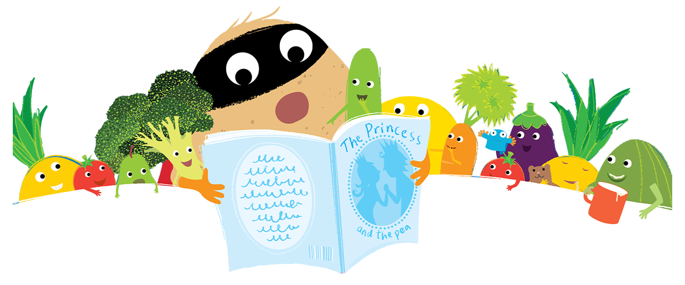
Topic Web Spring 1

Reading
Segmenting and blending phase 2 and phase 3 words
Read simple sentences
Read some common exception words
Show understanding of what they have read
Phonics
Consolidate Phase 2 Phonics sounds
Phase 3 Monster Phonics
Segmenting and blending
Reading and writing tricky words

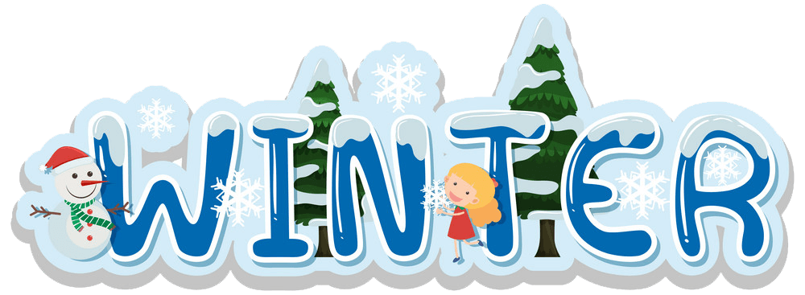

Numeracy
Tentown Numbers
Deep understanding 0-5
Combining two amounts
Subitizing
Bonds to 10
Comparing length & Height
Mass & Capacity
3D shapes

Literacy
Letter formation
Non-Fiction texts
Writing simple words and sentences using phase 2 & 3 sounds
Talk for writing
Writing some high frequency words correctly

Expressive arts & design
Rhythm using percussion
Music to accompany stories
Performing songs and stories
Use a variety of materials, tools and techniques in their creations.
Sing a range of well known nursery rhymes

RE
Why are some stories special?
Salvation
Showing love for others
Looking at ourselves, our families and the life of Jesus
PE
Gross and fine motor skills
Handling small and large equipment
Control and co-ordination
Spatial Awareness

Understanding of the world
Winter - Seasons
Ice/melting/freezing - experimenting
Cold places around the world - Animals that live there
Celebrations - Chinese New Year

