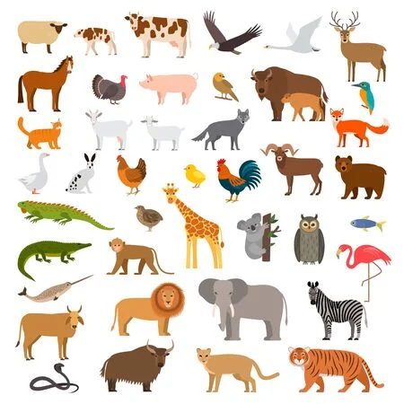

Expressive arts & design

Rhythm using percussion
Music in ‘Our World’
Combining and manipulating media to create new effects
Role play
Singing songs for routines
Nursery Rhymes
Performing

Understanding of the world
All Creatures Great and Small - Animals
Animals - observing, investigating, habitats, understanding how to look after pets, how to keep our world safe for animals
Reduce, Reuse, Recycle

