ANSON CE (A) PRIMARY SCHOOL

Main Road
Great Haywood
Stafford
ST18 0SU Tel no: 01889 881200
email office@anson.staffs.sch.uk

Headteacher: Mr Edward Howard BSc (Hons)

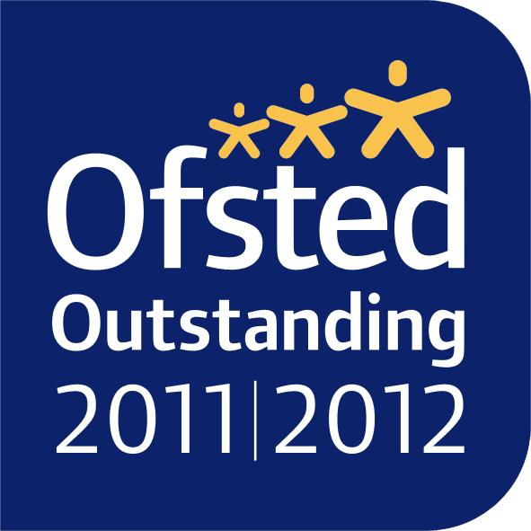
Dear Parents/Carers,

Welcome to a new term. We hope you all had a super Christmas! Class Three will begin the new term with a new history topic, all about Ancient Egypt! We will fully immerse ourselves in learning about the Ancient Egyptians by learning to locate the Ancient Egyptians in time and place, and learn all about their fascinating lives and culture.

Reminders
Targets: Your child will be working towards their individual targets which can be found in their homework diaries and have also been shared with you in a separate spring target letter. Your child will be working towards these targets in school but you can also support your child by working on these targets at home too. We would appreciate if you could sign these targets in your child’s homework diary.

Spellings: Class 3 spellings will continue to be given out on a Tuesday and are tested on the following Tuesday. Your child’s spelling lists are now uploaded on our school website and on the Spelling Shed app weekly so please encourage your child to practise at home, both verbally and in written form as well as through the fun games available on the Spelling Shed app. Your child’s spelling score will be recorded weekly in their homework diary. If you would like to support your child further, you will find a list of words that the children are expected to know by the end of Year 4 in the back of their homework diaries.

Homework: Homework will be sent out on a Wednesday and must be returned by the following Tuesday in the given homework book. Please encourage your child to take care with their homework, using neat handwriting in either a pencil or a pen. If your child has any difficulties with their homework, please put a note in their diary.

Reading: Reading books should be read each night for a minimum of 10 minutes with a focus on fiction stories. All reading at home should be recorded in the children’s diaries and signed by a parent/carer weekly. It is important that your child writes the name of the book and the pages that they have read. The children are listened to read in Guided Reading each week. In Class Three, children can earn a golden ticket if they have their diary signed at least four times a week. This ticket will be placed into the ‘golden bag’ and your child will have the chance to win a prize.

Water bottles: Each child should have a water bottle in school that is clearly named. The children can have a drink from these at any time throughout the school day and they are sent outside at breaks and lunches.

Uniform: Please ensure that all uniform, especially jumpers and cardigans are clearly labelled with your child’s name inside. Ties are expected to be worn with shirts or alternatively your child can wear a polo shirt. Where possible, please ensure clothing has the Anson logo.

PE: Please ensure that your child has an Anson PE top in their house colour and PE shorts. PE will be on a Tuesday afternoon so please make sure that your child brings in their kit at the beginning of the week. Swimming will continue to take place on a Friday afternoon. If your child needs to wear goggles, please ask Mrs Fenton for a form to sign.

Open Door Policy: Please feel free to contact me at school if you have any concerns, the open door policy at Anson means I am available for 15 minutes before or after school to talk through any problems. If you need longer, we can arrange a mutually agreeable time.

Kind Regards
Miss Humphries & Miss Vivash
Class 3’s Teacher and Teaching Assistant
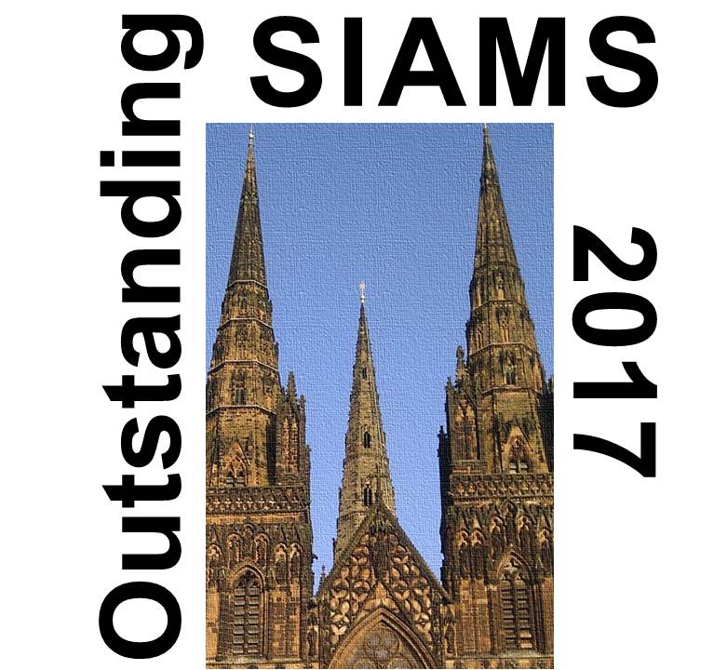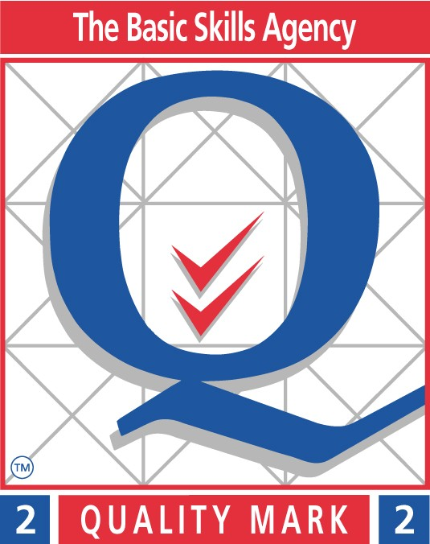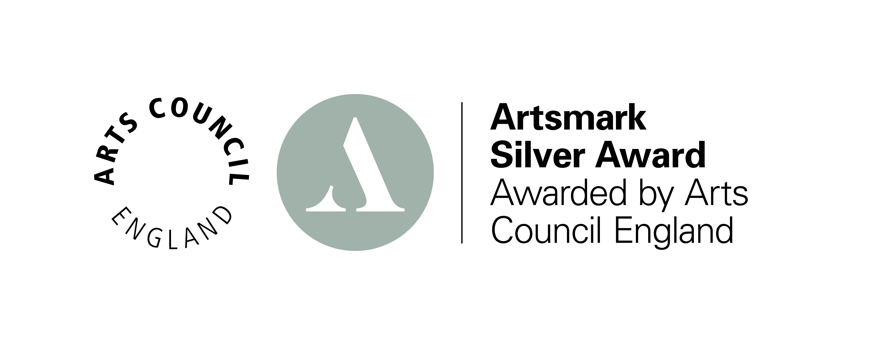
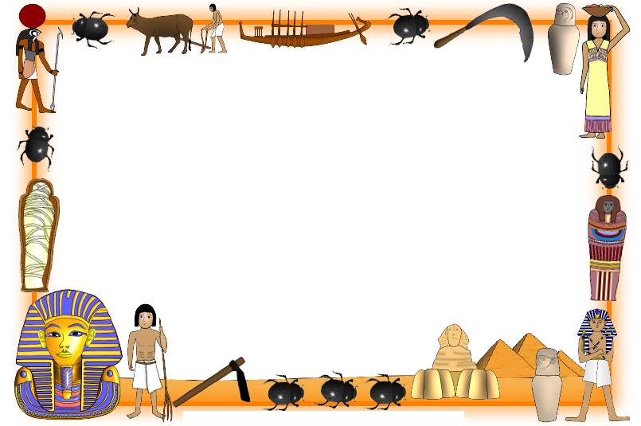
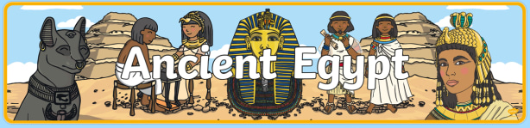

History
This term we will go back in time to the Ancient Egyptian times! We will fully immerse ourselves in learning about the Ancient Egyptians. We will learn to locate the ancient Egyptians in time and place, and learn all about their fascinating lives and culture.
Literacy:
We will be working on a range of fiction and non-fiction texts this term. Our first unit will be based around the story of The Egyptian Cinderella by Shirley Climo. The children will start the unit by engaging with the text through fun drama, discussion and debate activities in order to increase their understanding of the story. By the end of the unit pupils will plan their own story based on the structure of The Egyptian Cinderella and they will then have the opportunity to draft, edit and present their final narrative.
Numeracy:
The children will be focusing on a variety of areas. The first area we will be focusing on is measurement including solving problems involving measure, time and money.

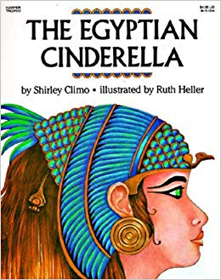

Science:
This term in science we are going to be exploring ‘Forces and Magnets’. Our class will explore pushes and pulls to uses for magnetic materials, your children will combine practical enquiry and scientific research to help them become more familiar with how forces and magnets work.

Art:
In art we will be making our own Egyptian cartouche. Firstly we will explore what a cartouche is and then plan and think about the steps involved in making our own out of clay. Along the way, we will have the chance to explore Ancient Egyptian hieroglyphics as we translate our names to create our own Egyptian name plate.
Computing:
We will be learning how to stay safe whilst using the internet. We will also be learning how to use a branching database.
P.E:
Swimming, Rugby and Hockey.
Religious Education:
Creation Story
P4C
Friendship and tolerance.
Music:
We will be learning how to appraise different types of music
French:

Introductions and simple commands.
French:
We will read and listen to the French story “J’ai un frere” Through the story we will learn to read, write and speak about our family in French.
Religious Education:
In RE we will be exploring what we know about Jesus. We will have the chance to look at varying representations of Jesus and explore whether any of these can be accurate before finding out what the Bible tells us about his personality, actions and life.
P.E:
Swimming & Tennis

Music:
Three Little Birds Unit
Computing:
This term we will improve our computing skills by learning how to use and format Spreadsheets.

