Spelling test: Year 5
Given: 28.6.22
Test: 6.7.22
water
bear
find
these
live
away

Spelling test: Year 5
Given: 28.6.22
Test: 6.7.22
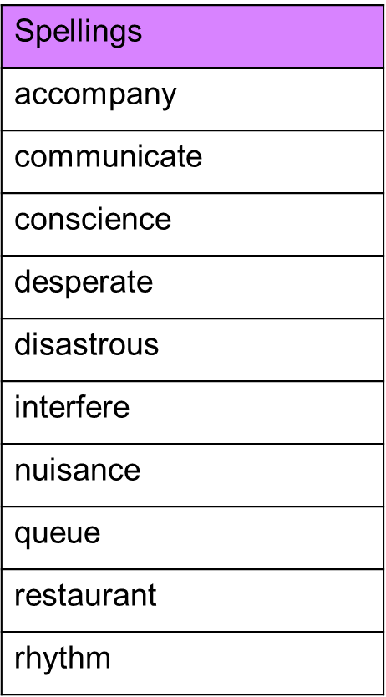

Spelling test: Year 6
Given: 28.6.22
Test: 6.7.22
