

**ANSON CE (A) PRIMARY SCHOOL**

**Main Road**

**Great Haywood**

**Stafford**

**ST18 0SU Tel no: 01889 881200**

**email** [**office@anson.staffs.sch.uk**](mailto:office@anson.staffs.sch.uk)

**Headteacher: Miss N. Jarrett**



Dear Parents/Carers

Welcome to a brand new school year! We hope you have had a fantastic summer during these strange new times! We are really looking forward to having the children back in school and we hope they are too! We have lots of exciting learning planned for this half term for our topic Awesome America. We will voyage across the Atlantic and discover the continents of North and South America and all their amazing countries, cities and landscapes. You can see details of all of the exciting learning we will be doing in the curriculum web attached to this letter.

**Reminders:**

**Spellings:** Class 4 spellings will continue to be given out on a Tuesday and are tested on the following Tuesday. Your child’s spelling lists are now uploaded on our school website and on the Spelling Shed app weekly so please encourage your child to practise at home, both verbally and in written form as well as through the fun games available on the Spelling Shed app. Your child’s spelling score will be recorded weekly in their homework diary. Please encourage your child to practice these spellings as knowing them will really help them succeed. If you would like to support your child further, you will find a list of words that the children are expected to know by the end of Year 6 in the back of the reading diaries.

**Homework Diaries:** Homework diaries are checked on a Friday in class 4 but should be in school daily. Please use the diaries to record your child’s reading at home and please sign the diary weekly. If you choose to use the diary as a form of communication, please encourage you child to show the teacher the message to ensure it is seen.

**Homework:** This term, due to schools closing during the lockdown period, it is vital that children focus on the fundamental learning skills of reading, spelling and times-tables recall. Please check the ‘Homework’ section of the school website weekly to find your child’s homework tasks.

**Open Door Policy:** Due to current circumstances, if you have any issues, please contact the school office so we can arrange a mutually convenient telephone appointment to discuss any problems.

**Uniform**: Please ensure that all uniform including jumpers are clearly labelled with your child’s name. Ties are expected to be worn with shirts – alternatively polo shirts can be worn. Please ensure clothing has the Anson logo.

**Water bottles**: Each child should have a water bottle in school that is clearly named. The children can have a drink from these at any time throughout the school day. Due to the current circumstances, water bottles will be sent home daily to be cleaned. Please ensure these are returned for the following school day.

**PE:** Please ensure that your child has an Anson PE top in their house colour, PE shorts and appropriate footwear. PE will be on a **Tuesday and Thursday afternoon** so please make sure that your child brings in their kit at the beginning of the week.

Can you also ensure that you read, complete and sign the permission forms on pages 5, 6 and 7 in your child’s homework diary.

Kind Regards,

Miss Spennewyn and Mrs Chell

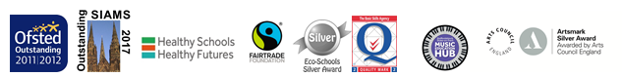Class 4’s Teacher and Teaching Assistant

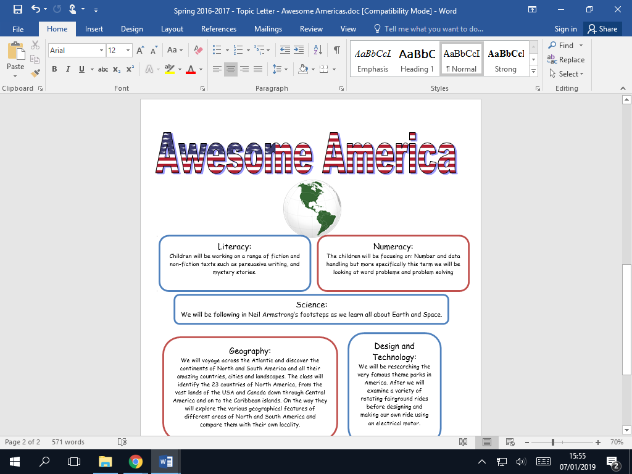

Computing:

In Computing, we will be looking at developing our coding skills, whilst also learning about how to stay safe online in our E-safety lessons.

French:

In French, we will be learning to use language relating to the classroom, such as commands and classroom objects.

Art and Design:

We will be looking at the artists Andy Warhol & Roy Lichtenstein and creating our own work based on their style!

Music

Our Music unit this term is called ‘Livin’ on a Prayer!’.

Religious Education:

Creation / Fall – Creation and science: conflicting or complementary?

Science:

We will be learning all about how light behaves before following in Neil Armstrong’s footsteps as we learn all about Earth and Space.

Literacy:

We will be working on a range of fiction and non-fiction texts such as persuasive writing, letter writing, poetry and mystery stories. For the first few weeks of term, we will also be looking at the book ‘After The Fall’ by Dan Santat, which looks at resilience and overcoming fears.

Geography:

We will voyage across the Atlantic and discover the continents of North and South America and all their amazing countries, cities and landscapes. The class will identify the 23 countries of North America, from the vast lands of the USA and Canada down through Central America and on to the Caribbean islands. On the way they will explore the various geographical features of different areas of North and South America and compare them with their own locality.

Numeracy:

In Numeracy, we will be focusing on a variety of mathematical areas, such as: place value; addition; subtraction; multiplication and division.