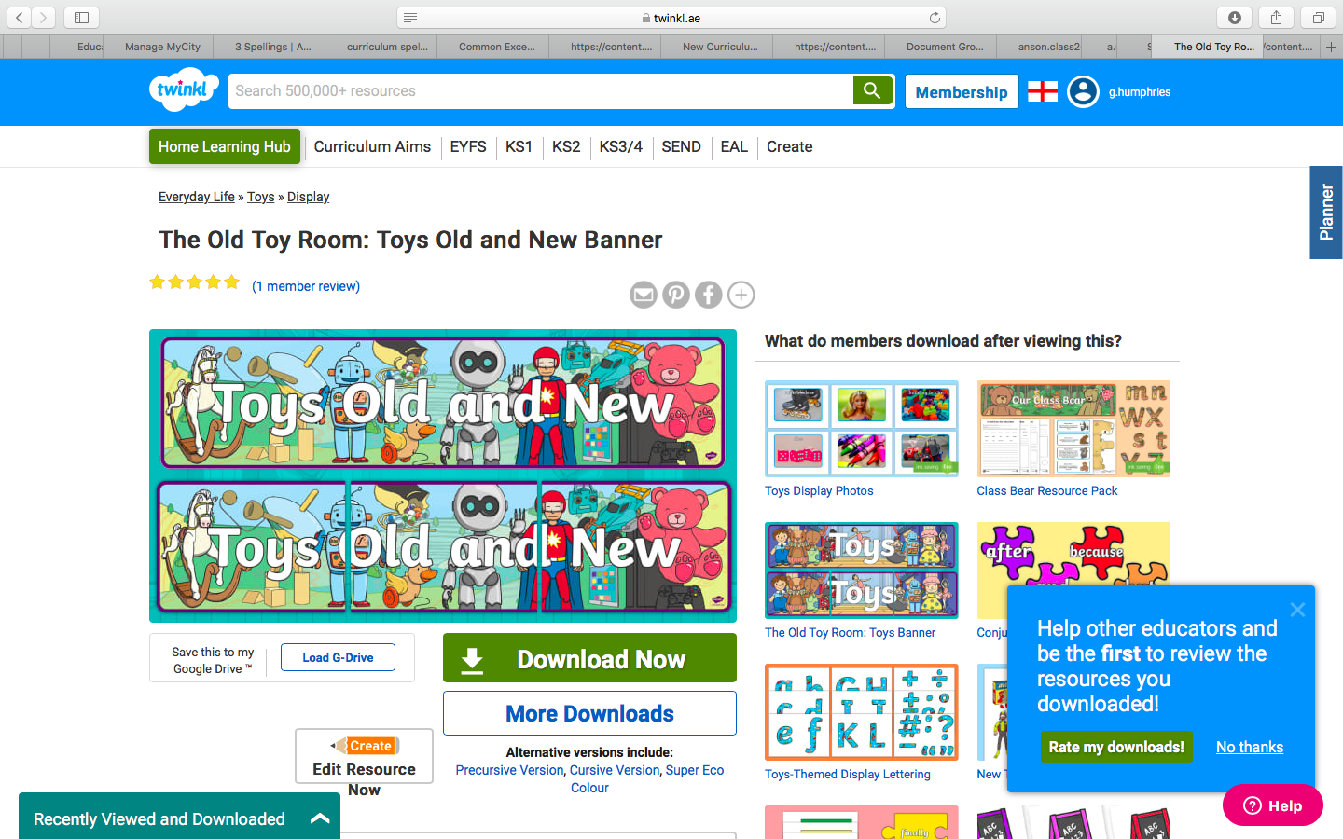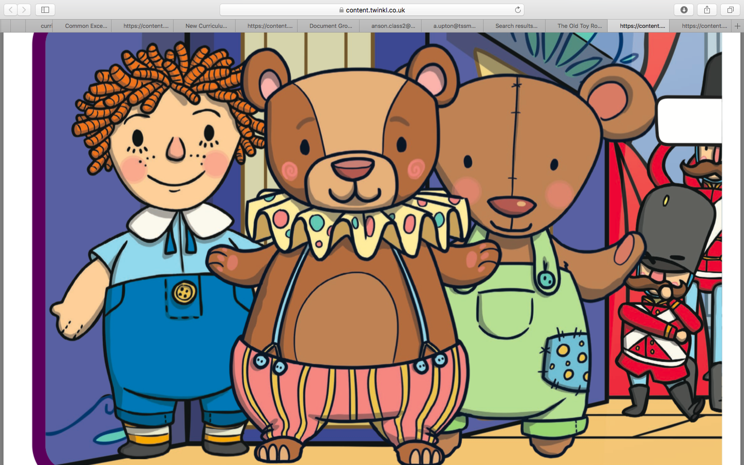

Create your own presentation all about ‘Toys Past and Present’.

Design and write a postcard to a family member or friend telling them all about your favourite toy.

Draw and label at least 5 old or new toys and put them into alphabetical order.

Describe how toys have changed from the past (think about the different materials etc).

Make a 3D model of an old toy.

Create your own board game.

Make a model using Lego.

Draw and label at least 5 old or new toys in alphabetical order.

**Half term Homework**

Next term we will be continuing our topic on ‘Toys Past and Present’.

Here are your home learning activities for our topic. You need to choose at least 1 activity from the boxes below to complete.

Please email a photo of your projects to the Class 2 email by **Monday 1st June**.

(You may also use this time to catch up on any home learning that you have not completed yet).