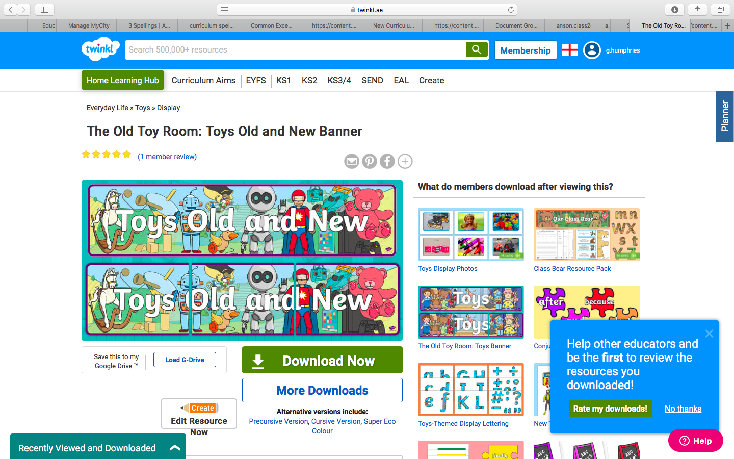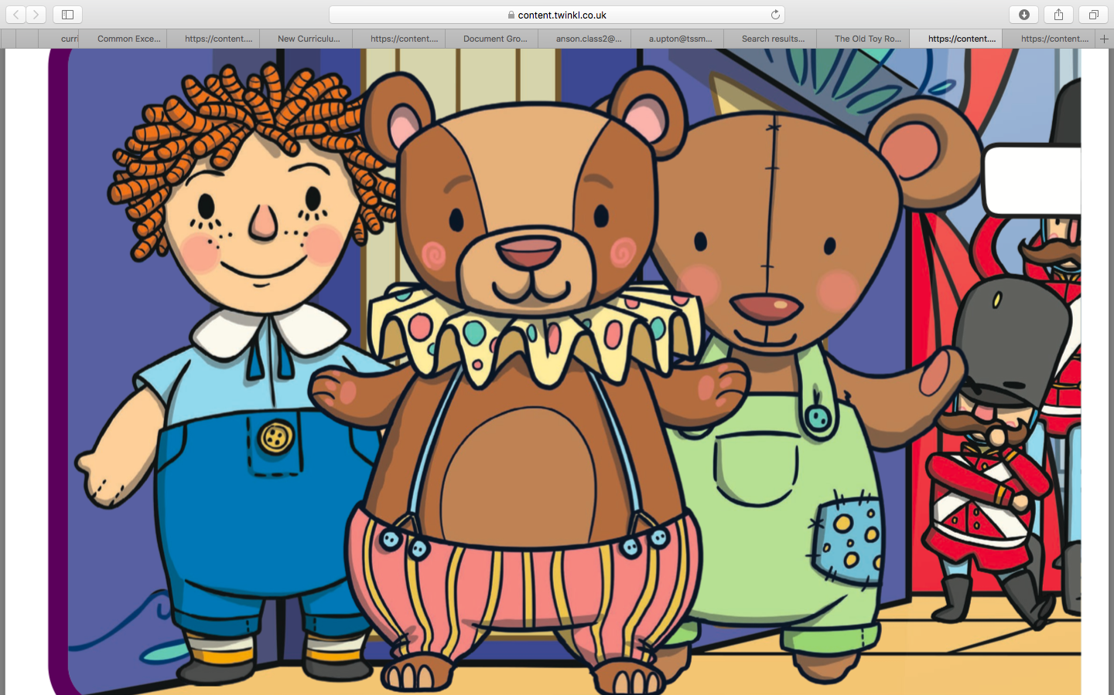

Create your own toy shop with some of your favourite toys. Give your toys some price tags. Take turns to be the shop keeper and customer.

Extra challenge: Buy two items and add to find the total.

Create a 3D model of a toy.

Interview grandparents/ older relative over the phone/ FaceTime about toys they played with when they were younger. E.g. toys they played with, their favourite toy, materials they were made from etc. Write down their answers.

**Easter Homework**

Our new topic for next term is ‘Toys past and Present’.

Here are your home learning activities for our topic. You need to choose at least 1 activity from the boxes below to complete.

Please email a photo of your projects to the Class 2 email by **Monday 20th April**.

Don’t forget to check the ‘Hall of Fame’ for regular updates!

Design your own board or toy.

Create a toy timeline.

Write a story about when your toys come to life. Think about ‘Toy Story’ for some inspiration. What your toys might get up to while you are asleep?

Create a picture of your favourite toy. You could, colour, paint or collage it.