

**ANSON CE PRIMARY SCHOOL**

**Main Road**

**Great Haywood**

**Stafford**

**ST18 0SU Tel no: 01889 881200**

**email** [**office@anson.staffs.sch.uk**](mailto:office@anson.staffs.sch.uk)

**Headteacher: Mr Edward Howard BSc (Hons)**

Dear Parents/Carers,

Welcome to a brand new term! We hope you had a fantastic Easter break! We have lots of exciting learning planned for this half term for our topic The United Kingdom. We will learn about the countries, counties and cities of the UK as well as learning about the human and physical features of Great Britain, such as the population, the tallest mountains, the longest rivers, the coastline and much, much more! You can see details of all of the exciting learning we will be doing in the curriculum web attached to this letter.

**Reminders:**

**Spellings:** Class 4 spellings will continue to be given out on a Tuesday and are tested on the following Tuesday. Your child’s spelling lists are uploaded on our school website and on the Spelling Shed app weekly so please encourage your child to practise at home, both verbally and in written form as well as through the fun games available on the Spelling Shed app. Your child’s spelling score will be recorded weekly in their homework diary. Please encourage your child to practice these spellings as knowing them will really help them succeed. If you would like to support your child further, you will find a list of words that the children are expected to know by the end of Year 6 in the back of the reading diaries.

**Homework Diaries:** Homework diaries are checked on a Friday in class 4 but should be in school daily. Please use the diaries to record your child’s reading at home and please sign the diary weekly. If you choose to use the diary as a form of communication, please encourage your child to show the teacher the message to ensure it is seen.

**Homework:** Please check the ‘Homework’ section of the school website on a Thursday to find your child’s homework tasks for that week.

**Open Door Policy:** Please do not hesitate to contact me at school if you have any concerns. The open door policy at Anson means I am available for 15 minutes before or after school to talk through any problems. If you need longer, we can arrange a mutually agreeable time.

**Uniform**: Please ensure that all uniform including jumpers are clearly labelled with your child’s name. Ties are expected to be worn with shirts – alternatively polo shirts can be worn. Please ensure clothing has the Anson logo.

**Water bottles**: Each child should have a water bottle in school that is clearly named. The children can have a drink from these at any time throughout the school day.

**PE:** Please ensure that your child has an Anson PE top in their house colour, PE shorts and appropriate footwear. PE will be on a **Monday and Friday** so please make sure that your child brings in their kit at the beginning of the week.

Kind Regards,

Miss Spennewyn, Mrs Castell, Mrs Chell and Miss Roper

Class 4’s Teacher and Teaching Assistants

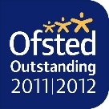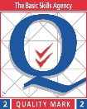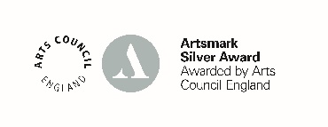

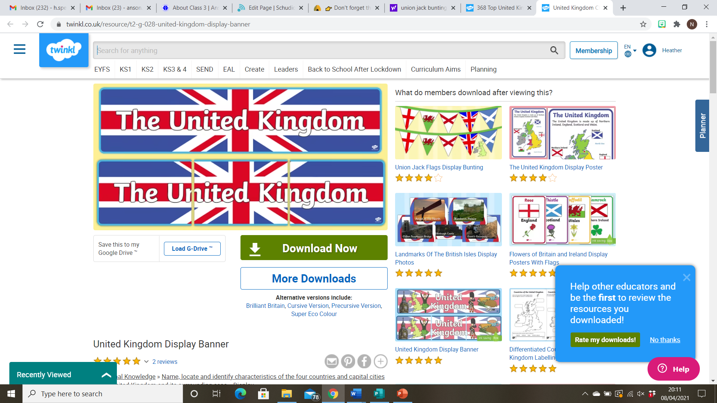

Literacy:

We will be working on a range of fiction and non-fiction texts such as discussion texts, biographies and script writing, learning all about William Shakespeare and the creation of HS2!

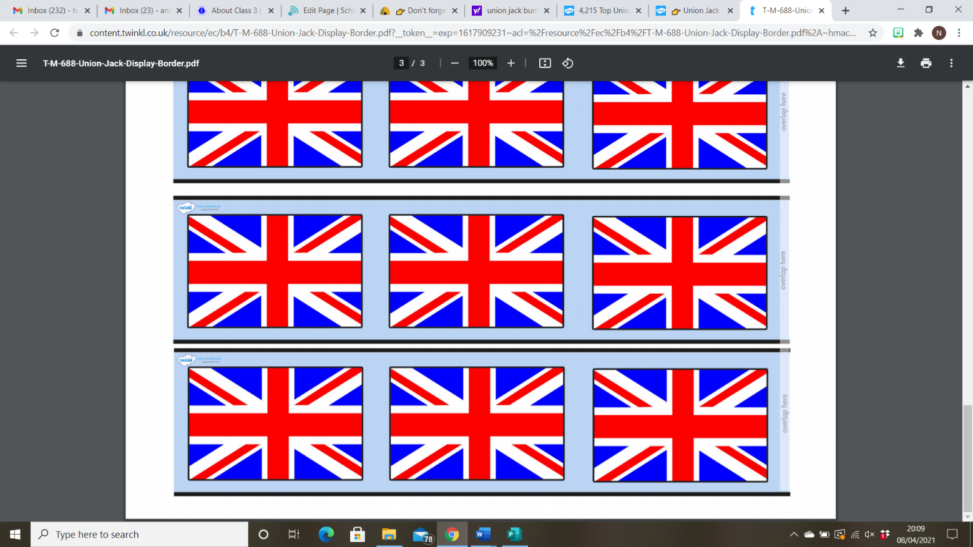

Numeracy:

This term, Year 5 will be continuing their unit on Decimals and Percentages, before moving onto learning about Statistics and Shape. Year 6 will also be learning about Statistics and Shape and will be honing their reasoning skills ready for SAT’s!

Geography:

In Geography, Class 4 will learn about the countries, counties and cities of the UK as well as learning about the human and physical features of Great Britain, such as the population, the tallest mountains, the longest rivers, the coastline and much, much more!

Science:

Class 4 will be learning about Lifecyles in Science, comparing the life cycles of different animals around the world and learning about famous naturalists such as Charles Darwin and Carl Linnaeus. We will then move onto learning about different ways in which we can classify animals and organisms.

Religious Education:

In R.E, we will be completing a unit called ‘What does it mean to be Jewish?’,

Art/D.T:

We have lots of exciting, hands-on learning planned this term! We will be designing and creating a cushion using our sewing skills, and then doing some construction work using saws and hammers to create our own bird houses!

Physical Education:

Class 4 will be improving their skills in Athletics and cricket.