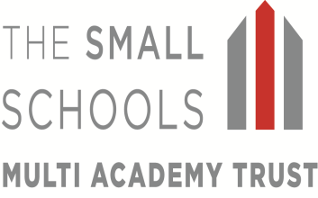

12th May 2020

Dear Parents and Carers,

I hope that you and your families are well and that you are coping during these extremely difficult times. As you will no doubt already know the Government has introduced new guidance for us to follow. The guidance states that schools should be open for children in Reception, Year 1 and Year 6 from the 1st June 2020 at the very earliest! For schools that have nursery children such as St Mary’s and Richard Crosse, the guidance states that nursery children should also be catered for.
The purpose of my letter is to reassure you that we are doing all we can to try and reopen our schools as safely as possible. I am sure you will appreciate that there is a lot to be taken into account and I am not in a position to be able to inform you of our precise plans at the moment.

We have already received a lot of correspondence from parents of children in Years 2, 3, 4 and 5 saying that from June 1st their children will need to attend school as they are Keyworkers. Whilst we would like to be able to accommodate everyone’s needs, this may simply not be possible as the Government has restricted class sizes to a maximum of 15. We need to keep everyone safe by maintaining social distancing and therefore, all schools will not be able to return to normal, as our capacity will be severely reduced.

Please be aware that whilst our schools will start to reopen, it will not be business as usual. It is most likely that we will not be in a position to offer full time schooling for some time and children will attend on a part time basis. It may also be necessary to limit schooling to children of Keyworkers in Tier 1 only, as per a previous communication with you.

As I said at the start of my letter, we are in the very early stages of planning as we have only just received guidance from the Department of Education. If you feel that your child is entitled to attend school as you are Keyworkers, please would you contact your school to let them know as this will aid our planning.

Please be assured that we are doing our very best at this difficult time. Unfortunately, none of us has the perfect answer to the situation we find ourselves.

In the meantime, stay safe and take care!
Yours sincerely,
Mr P J Lovern
Chief Executive Officer

