Spelling test: Year 5
Given: 5.11.19
Test: 12.11.19
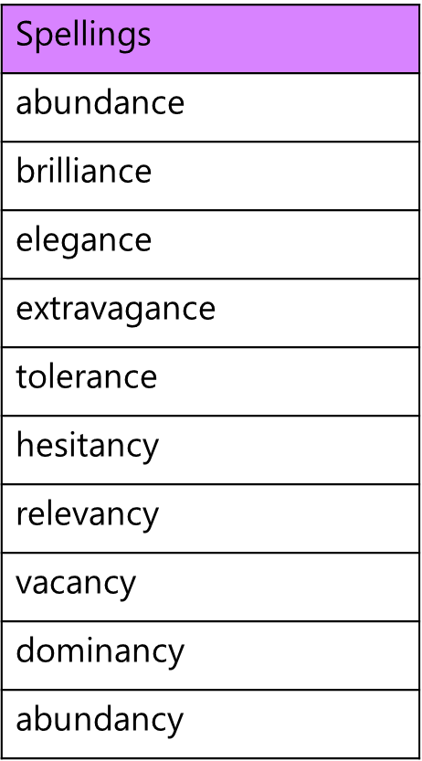

Spelling test: Year 6
Given: 5.11.19
Test: 12.11.19
