Spelling test: Year 5
Given: 8.6.21
Test: 15.6.21
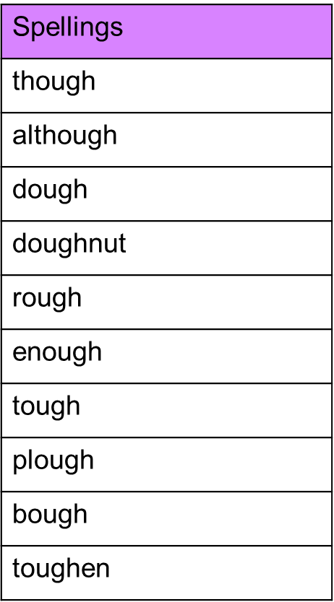

Spelling test: Year 6
Given: 8.6.21
Test: 15.6.21
