Spelling Test: Year 5
Given: 11.1.22
Test: 18.1.22
Rule: High Frequency Words
Spellings
much
so
were
over
water
now

Spelling test: Year 5
Given: 11.1.22
Test: 18.1.22
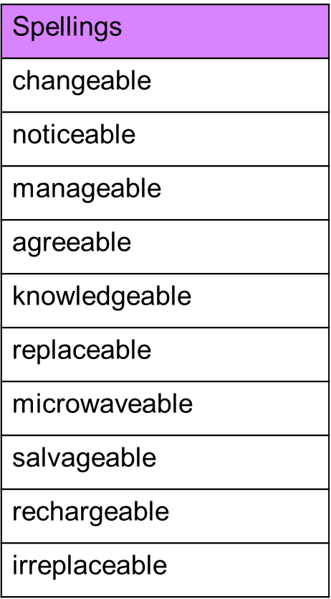

Spelling test: Year 6
Given: 11.1.22
Test: 18.1.22