Spelling test: Year 5
Given: 21.4.20
Test: 28.4.20
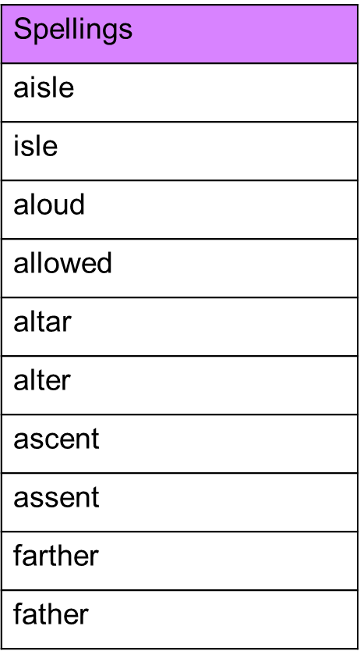

Spelling test: Year 6
Given: 21.4.20
Test: 28.4.20
