Spelling test: Year 5
Given: 8.9.20
Test: 15.9.20
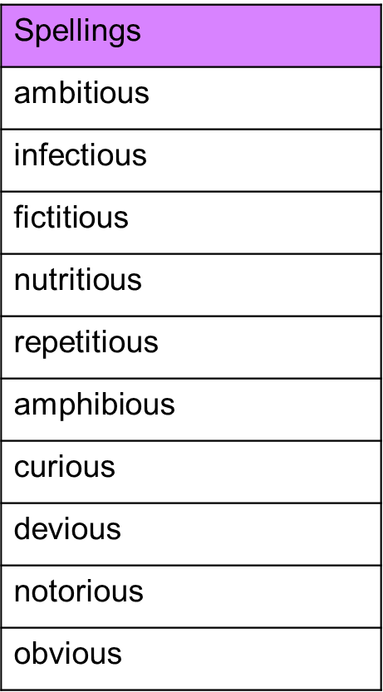

Spelling test: Year 6
Given: 8.9.20
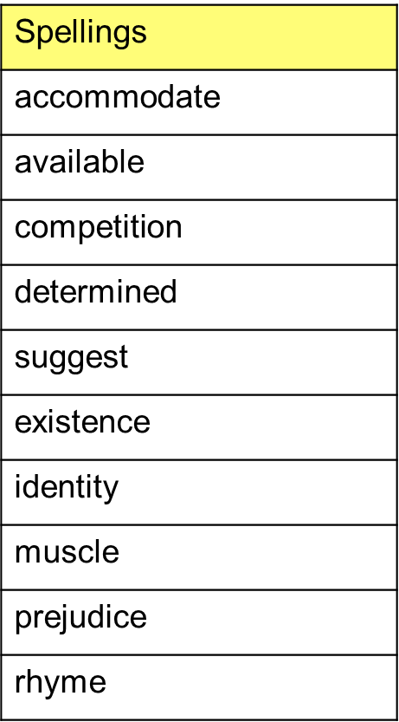
Test: 15.9.20

