Spelling test: Year 5
Given: 3.11.20
Test: 10.11.20
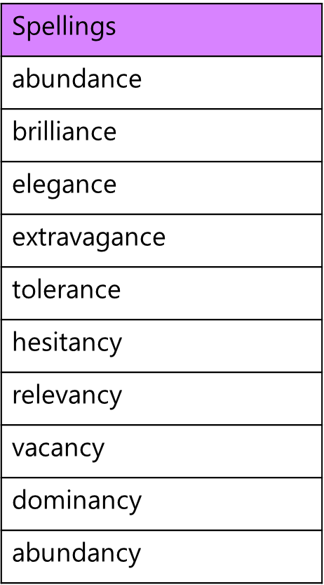

Spelling test: Year 6
Given: 3.11.20
Test: 10.11.20
