Spelling Test: Year 5
Given: 11.11.21
Test: 18.11.21
Rule: High Frequency Words
Spellings
many
seen
who
once
too
name

Spelling test: Year 5
Given: 11.11.21
Test: 18.11.21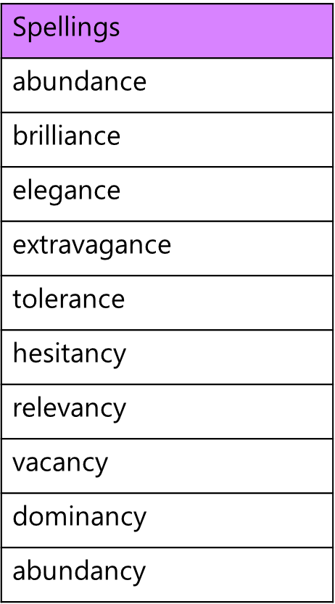

Spelling test: Year 6
Given: 11.11.21
Test: 18.11.21