Spelling test: Year 5
Given: 28.4.20
Test: 5.5.20
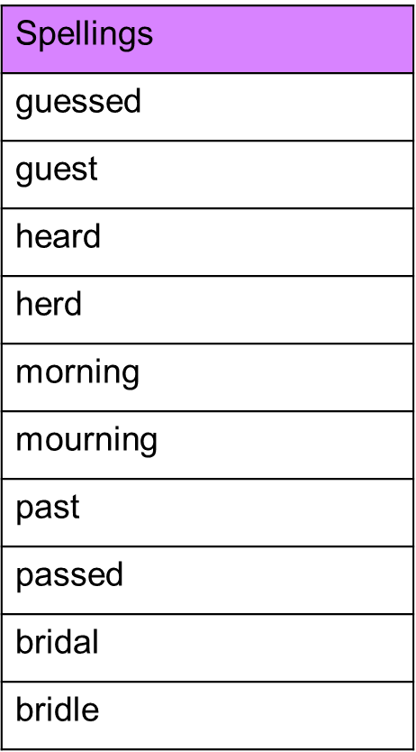

Spelling test: Year 6
Given: 28.4.20
Test: 5.5.20
