Spelling test: Year 5
Given: 15.9.19
Test: 22.09.19
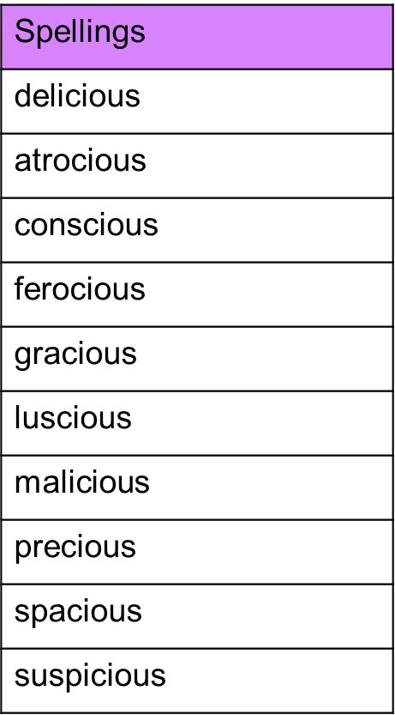

Spelling test: Year 6
Given: 15.9.19
Test: 22.09.19
