Spelling test: Year 5
Given: 23.3.21
Test: 30.3.21
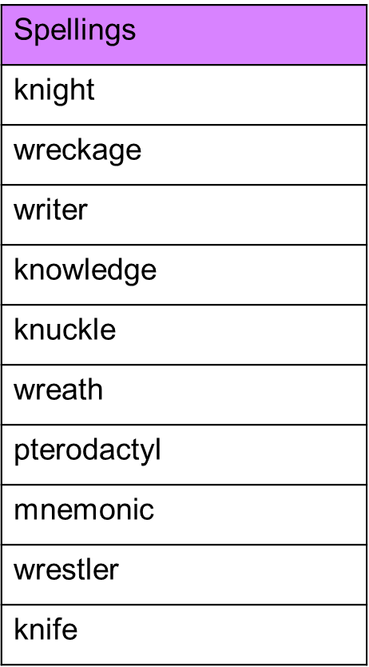

Spelling test: Year 6
Given: 23.3.21
Test: 30.3.21
