Spelling Test: Year 5
Given: 14.9.21
Test: 21.9.21
Rule: High Frequency Words
Spellings
has
but
him
do
that
low

Spelling test: Year 5
Given: 14.9.21
Test: 21.9.21
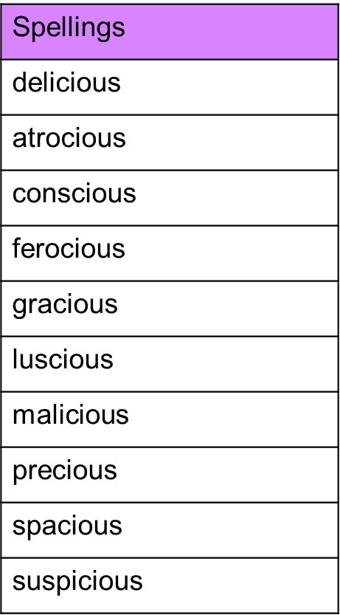

Spelling test: Year 6
Given: 14.9.21
Test: 21.9.21
