Spelling test: Year 5
Given: 19.11.19
Test: 26.11.19
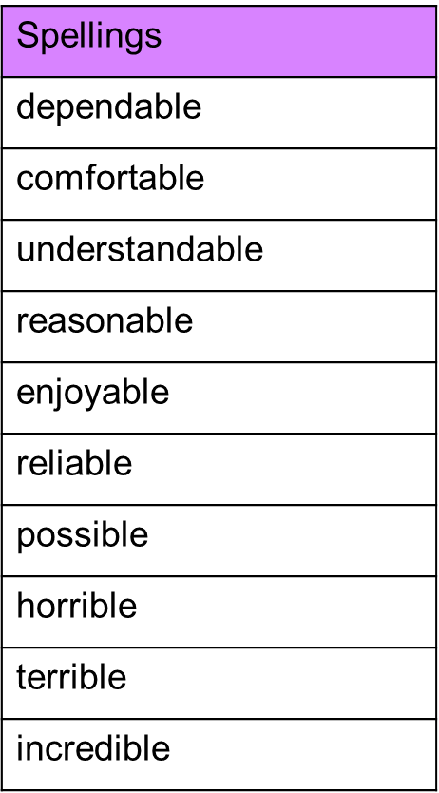

Spelling test: Year 6
Given: 19.11.19
Test: 26.11.19
