Spelling Test: Year 5
Given: 21.9.21
Test: 28.9.21
Rule: High Frequency Words
Spellings
by
just
called
made
don’t
make

Spelling test: Year 5
Given: 21.9.21
Test: 28.9.21
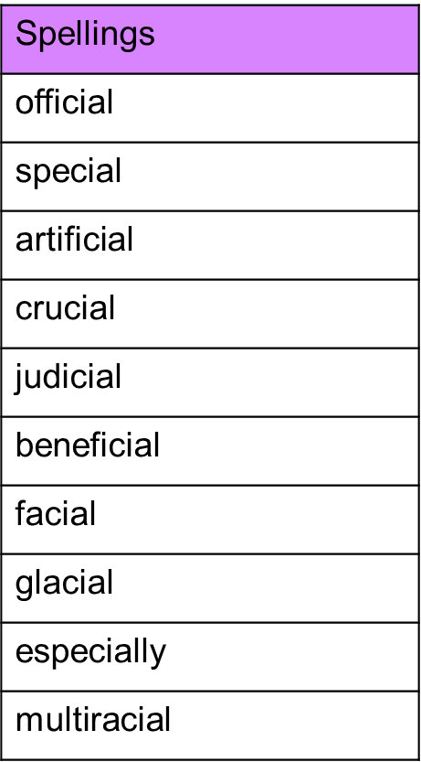

Spelling test: Year 6
Given: 21.9.21
Test: 28.9.21
