Spelling Test: Year 5
Given: 25.1.22
Test: 1.2.22
Rule: High Frequency Words
Spellings
three
eight
thirteen
eighteen
orange
brown

Spelling test: Year 5
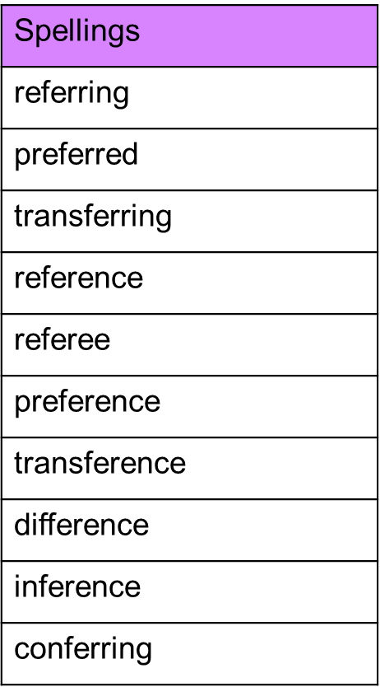
Given: 25.1.22
Test: 1.2.22

Spelling test: Year 6
Given: 25.1.22
Test: 1.2.22

