Spelling test: Year 5
Given: 5.5.20
Test: 12.5.20
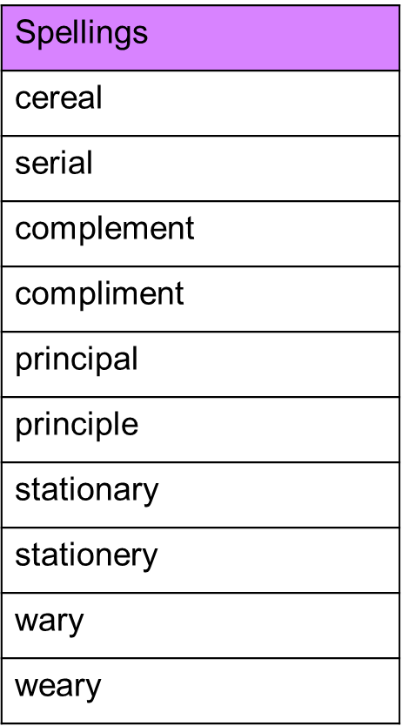

Spelling test: Year 6
Given: 5.5.20
Test: 12.5.20
