Spelling test: Year 5
Given: 22.9.20
Test: 29.9.20
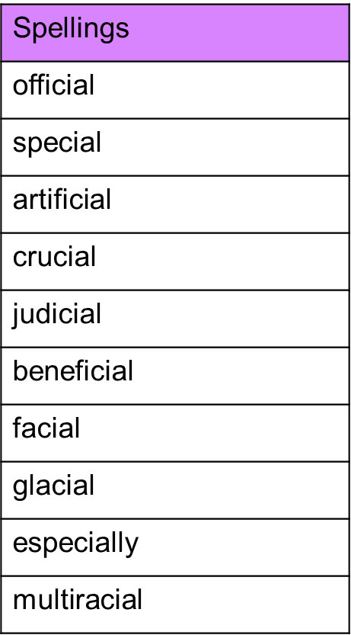

Spelling test: Year 6
Given: 22.9.20
Test: 29.9.20
