Spelling test: Year 5
Given: 17.11.20
Test: 24.11.20
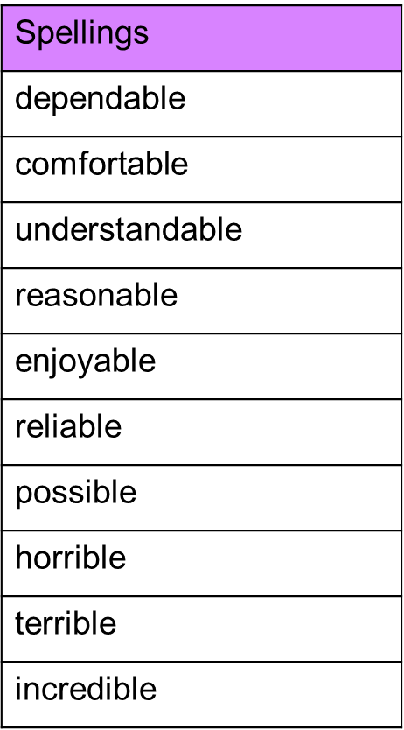

Spelling test: Year 6
Given: 17.11.20
Test: 24.11.20
