Spelling Test: Year 5
Given: 23.11.21
Test: 30.11.21
Rule: High Frequency Words
Spellings
two
seven
twelve
seventeen
red
white

Spelling test: Year 5
Given: 23.11.21
Test: 30.11.21
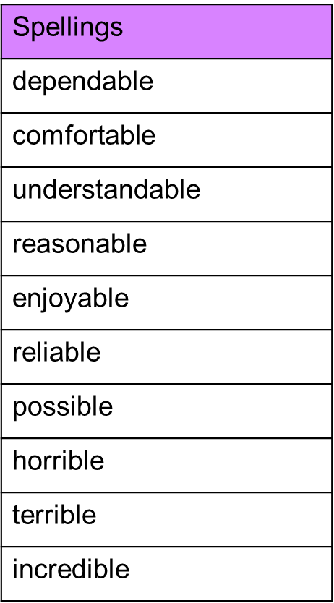

Spelling test: Year 6
Given: 23.11.21
Test: 30.11.21