Spelling Test: Year 5
Given: 4.2.22
Test: 8.2.22
Rule: High Frequency Words
Spellings
as
got
little
jump
put
us

Spelling test: Year 5
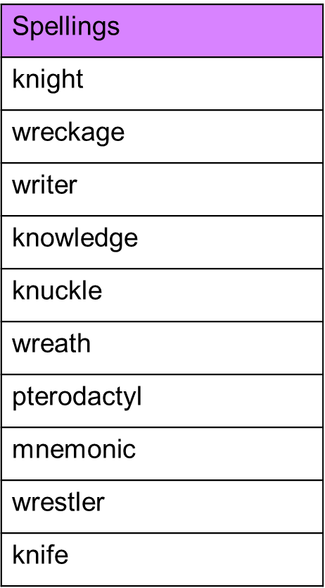
Given: 4.2.22
Test: 8.2.22

Spelling test: Year 6
Given: 4.2.22
Test: 8.2.22
